11AC 600Mbps Nano-Sized Wireless USB Adapter
WL-700-AC

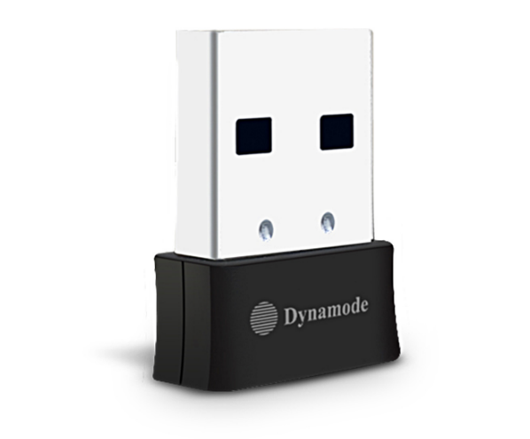

Descrption:
The exciting WL-700-AC is a new generation of high performance, nano-sized 802.11ac USB wireless adapters that's ideal for the next generation of applications including 4K HD streaming, online gaming as well as super-fast web browsing and other Internet activities, all in a totally compact USB form factor.
Featuring a highly integrated, next generation antenna system, allowing for up to 600Mbps WiFi speeds complete with auto 2.4Ghz
or 5Ghz connection, ideal for highly congested WiFi networks. The ideal notebook solution for Windows(tm) and Mac(tm) OS X operating systems with total Plug n' Play setup.

Features:
- Dual-band 802.11AC WiFi
- Automatic 2.4Ghz or 5Ghz for less congestion
- Super-fast, up to 600Mbps WiFi performance
- Nano-sized form factor, ideal for your notebook USB
- Ideal for the latest Broadband routers and Mesh WLANs
- Plug n' Play for Windows(tm), Mac(tm) OS X and Linux(tm)

SPECIFICATIONS:
- Chipset Solution: Realtek 8811CU
- Interface Type: USB 2.0
- Standards: IEEE802.11 ac/a/b/g/n
- Antenna: 2dBi Internal PIFA Antenna
- Frequency Band: 2.412~2.484GHz , 5.18-5.825GHz
- Modulation type: CCK, OFDM, DBPSK,DQPSK,256QAM
- Wireless data rate: 11ac: Up to 433Mbps 11n: Up to 200Mbps 11g: Up to 54Mbps
- Receive Sensitivity: 433M: -61dBm@10% PER 150M: -72dBm@10% PER 54M: -72dBm@10% PER
- 11M: -85dBm@8% PER
- Typical Tx Power (E.I.R.P): 18dBm
- Dimension: 19.5 x 14.5 x 7.2mm
- Supported OS(auto install): Windows(tm) 7/8/8.1/10 and Mac(tm) OS X
- Security: 64/128-bit WEP, WPA, WPA2, WPA-PSK, TKIP, AES
- Voltage Range: 4.7-5.2V
- Operating Temperature: 0°C~40°C
- Storage Temperature: -20~60°C
- Operating Humidity: 10%~85% non-condensing
- Storage Humidity: 5%~95% non-condensing

